Computer Science Department

University of Computer & Emerging Sciences (FAST-NUCES)

HOME WORK ASSIGNMENT COVER SHEET

COURSE TITLE Software Design & Analysis COURSE CODE CS3004

INSTRUCTOR DR. EJAZ AHMED TYPE √ (Please tick)
Indiv. Group
ASSIGNMENT NO HW-2 (Class)

ASSIGNMENT Use Case Diagram and Development of Template of POS

HAND OUT DATE 25-SEP-2025 DUE DATE 05-OCT-2025

ESTIMATE TIME 8 Hours

ASSESSMENT CRITERIA (or attached) | % Mark
Questions are attached (print copy)

This HW includes the following tasks (Total 4)
Requirement Analysis, Iterations, Use Case Diagram and Use Case Detailed Template

Submission: Any mistake or missing material will lead to the reduction of 5% marks.

Group of max 3 students is allowed, individual work is discouraged with 10% deduction

TO BE COMPLETED BY STUDENT (TEAM LEAD) GROUP MEMBERS ID
ID 23i-0523 Sec# F
ID 23i-0730 Sec# F
ID 23i-0528 Sec# F

NAME Muhammad Moiz Ansari

ID NO 23i-0523 Section# F

Time Taken ~ 8 Hrs.

DECLARATION: I/We declare that this Coursework is my/our group’s own work

SIGNATURES (All members)

GRADE/ MARK AWARDED COMMENTS

INSTRUCTOR’S SIGNATURE DATE

Table of Contents
HOME WORK ASSIGNMENT COVER SHEET 1
REQUIREMENTS ANALYSIS 3
Functional Requirements 3
Non-Functional Requirements 3
ITERATIONS 3
Use Case Diagram 5
UI using Java FX 6

REQUIREMENTS ANALYSIS

Functional Requirements

- Manage Bills and Customers

- Generate bills for customers.
- Assign bill numbers automatically
- Capture necessary customer information (name, contact, etc.)

- Item Search

- Search medicines by brand name or barcode number.
- Display medicine details.

- Sales

- Add multiple items to the bill.
- Update item quantities.
- Apply discounts(if applicable).
- Handle different payment methods.
- Automatically calculate subtotal, discount, net total, and taxes.
- Print the customer invoice with the bill number, date/time, item details, customer details, total amount, discount, and balance.

- Stock Handling

- Display current stock.
- Alert the cashier if the stock is insufficient.
- Prevent the sale of expired medicine.

Non-Functional Requirements

- USABILITY: Simple UI for easy use and quick transactions.
- PERFORMANCE: The System must generate invoices quickly.
- SCALABILITY: Should handle multiple users without affecting performance.
- RELIABILITY: The System should not lose data in case of a power failure.
- SECURITY: Customer data and billing records must be secure.

ITERATIONS

- Iteration 1: Sales Process
- Implement basic bill creation.
- Search/Select items.
- Add items to the cart.
- Calculate totals/discounts/taxes.
- Generate/Print invoices.
- Handle multiple payment methods.

- Iteration 2: Customer Management
- Register customers by capturing their details.
- Store customers' past bills.
- Display customers’ purchase history.

- Iteration 3: Stock Handling
- Implement checks for stock availability.
- Update stock after each sale.
- Track expiry dates.

- Iteration 4: Security
- Implement a login system for the cashier.
- Track cashier ID for each transaction.

Use Case Diagram

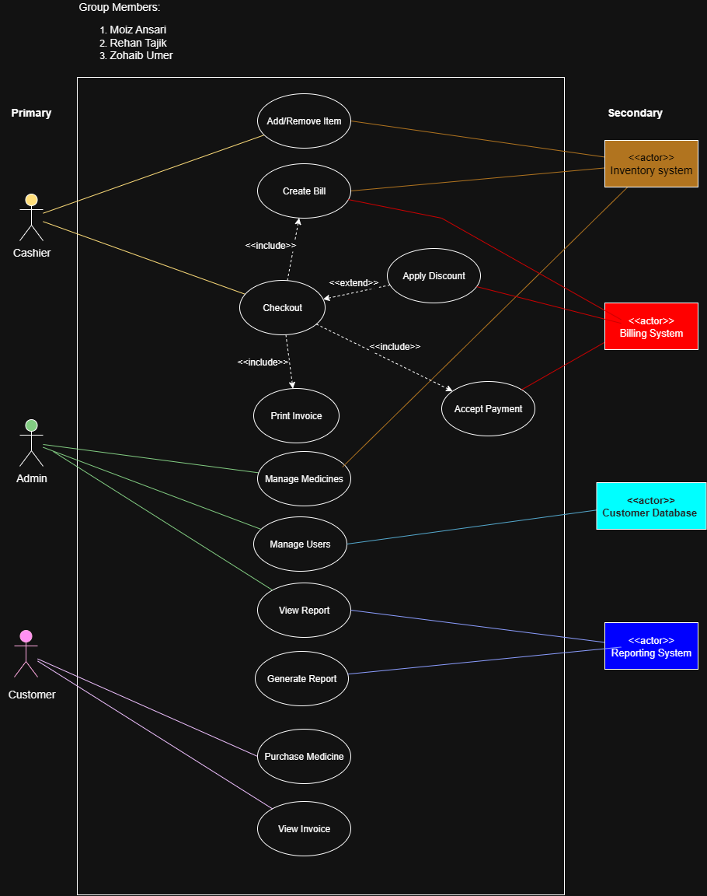

UI using Java FX

